**Computer Architecture**

# Program Execution

1. **Main Memory**
   1. Fast
   2. Large
   3. cheap
2. **System Bus**
3. **Processor**
4. **Input/output**



# Hierarchy of memory

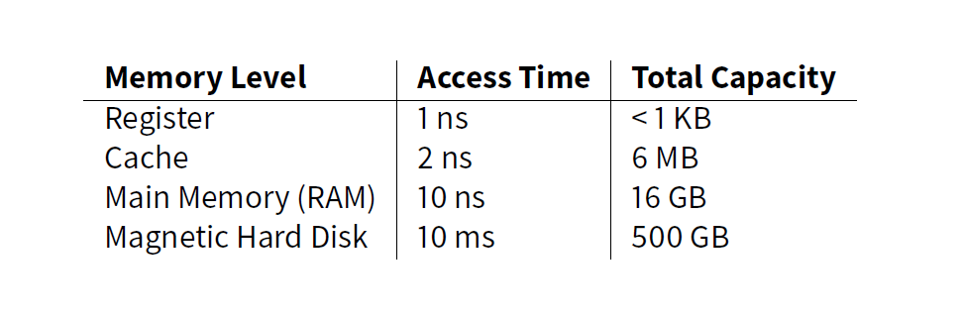

* **Different levels of memory at different sizes, speed, and cost.**

# System Bus

* Every sort of communication using the same bus.

# CPU

* Fetch-Decode-Execute cycle repeats until the program finishes.
* Different steps may be completed in parallel (**pipeline**).
* Processor’s largest unit is the **word**.
  + 32-bit computer -> 32-bit word
  + 64-bit computer -> 64 bit word
* CPUs have storage locations: **registers**
  + They may store data or instructions
* A few of registers in a typical CPU:
  + Programmer Counter
    - Next instruction
  + Status Register
    - Array of bits to indicate flags
  + Instruction Register
    - Instruction most recently fetched
  + Stack Pointer
    - Top of the stack
  + General Purpose Registers
    - Store data, addresses, etc.

# Program Execution

* Program is a sequence of instructions.
  + **Processor-Memory**
  + **Processor- I/O**
  + **Data Processing**
  + **Control**

# Interrupts

* Source of interrupts (4 kinds)
  + **Program**
  + **Timer**
  + **Input / Output**
  + **Hardware Failure**

# Storing and Restoring State

* The OS must store the program state when an interrupt occurs/multiprogramming
* The state must be stored
* State: values of registers
* Push them onto the stack
* Interrupt finished: restore the state (pop off the stack)
* Then execution continues

# I/O Communication

* Three major strategies for communication
  + Programmed I/O
    - **Polling**
  + Interrupt Driven I/O
    - **Interrupts**
  + Direct Memory Access (DMA)
    - CPU does setup indicating
      * The operation to perform (read or write)
      * The source
      * The destination
      * How much data is to be transferred
    - This data is sent to the DMA module ( a delegate)
    - The CPU can go on to do other work
    - The I/O device will interact directly with memory.